Unit 9
Assignment
Long Vy
Purdue Global
IN450 – Advanced Software Development Using Python
Brian Myers
May 25, 2026

Introduction
The Unit 3 project was a Python GUI login application built with Tkinter that authenticated users against a PostgreSQL database and displayed role-based table data. The application was developed using Tkinter login form techniques documented by w3resource (2025) and database login page patterns from GeeksforGeeks (2025). While the application fulfilled its functional requirements, a review of the codebase against established software security principles revealed several significant vulnerabilities. The Software Engineering Body of Knowledge (SWEBOK) states that it is much better to design security into software than to patch it in after the software is developed, and it identifies secure software construction as a critical stage in the software development lifecycle (Bourque & Fairley, 2014, p. 13-25). This paper documents four security changes applied to a cloned copy of the Unit 3 project. Each change is explained in terms of the technique used, with before-and-after code comparisons provided throughout. The paper concludes with an assessment of how the combined changes improve the overall security posture of the application.

Security Change 1: Input Validation and Sanitization

Technique Implemented
The first security change implements strict input validation on the username field using Python's re module to enforce a whitelist regular expression pattern. Only alphanumeric characters and underscores are accepted, and the username length is capped at 50 characters. Cymulate (2025) defines input validation as the process of verifying that data entered into a system meets predefined criteria before it is processed or stored, and identifies it as a foundational defense against injection attacks and other forms of malicious input. This aligns with the SWEBOK guidance that developers should validate all input and sanitize data sent to other software, which are listed as the first and seventh of ten recommended CERT security practices for software construction (Bourque & Fairley, 2014, p. 13-26). This change also corrects a secondary issue in the original code, where raw Python exception text was displayed directly in the user interface. Exposing internal error details can give attackers useful information about the system, so the updated version displays only a generic message to the user while printing technical details to the server console instead.

Before Code
In the original Unit 3 code, based on the Tkinter login patterns from w3resource (2025) and GeeksforGeeks (2025), the login() function retrieved the username and password with no format checks and forwarded any exception message directly to the user interface. The following excerpt shows the original approach.
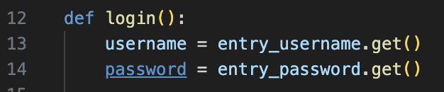
No validation — any string passed through

After Code
The secured version adds an is_valid_username() function and calls it before any database interaction takes place. The raw exception message is replaced with a generic notice, and the technical details are redirected to the server log. The following excerpt shows the updated approach.

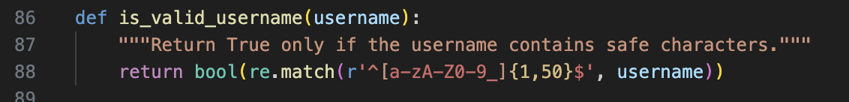
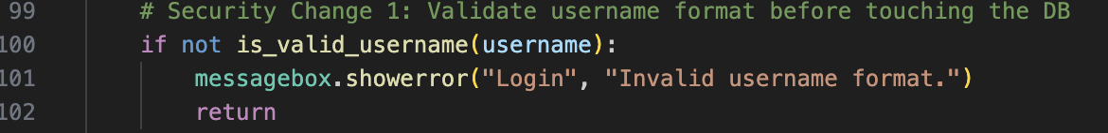
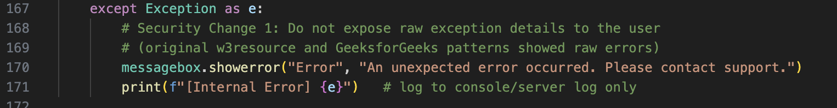

Security Change 2: Parameterized Queries and Application Service Account

Technique Implemented
The second security change addresses two related vulnerabilities present in the original implementation. The original application, modeled on the GeeksforGeeks (2025) database login pattern, passed the end-user's username and password directly as the PostgreSQL connection credentials, which bypassed the possibility of application-layer authentication controls. Additionally, there was no parameterized query layer, meaning user input could flow directly into database operations. Amezola (2023) explains that SQL injection occurs when user input is not properly sanitized and is directly concatenated into SQL queries, which allows attackers to manipulate query logic in harmful ways. The recommended fix is to use parameterized queries, where psycopg2 percent-sign placeholders bind user data as a value rather than as executable code. SWEBOK supports this approach through its guidance that developers should adhere to the principle of least privilege, which also informed the decision to introduce a dedicated application service account with restricted database permissions rather than authenticating with end-user credentials (Bourque & Fairley, 2014, p. 13-26). Applying both fixes together removes the primary injection risk and narrows the database permissions available to the running application.

Before Code
In the original Unit 3 code, the database connection string directly embedded user-supplied credentials, making it impossible to validate or hash them before use. The following excerpt shows the original approach.
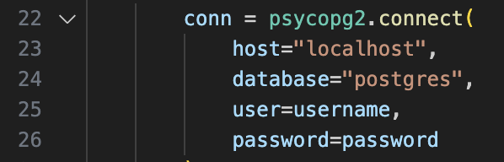

After Code
The secured version connects with a fixed service account and uses a parameterized SELECT statement to look up the user. For table names, which psycopg2 cannot parameterize, an explicit whitelist is checked before interpolation, following the guidance provided by Amezola (2023). The following excerpt shows the updated approach.
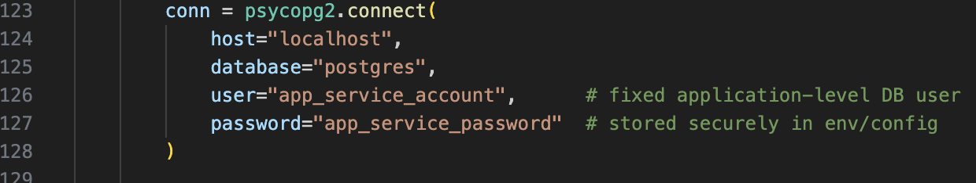
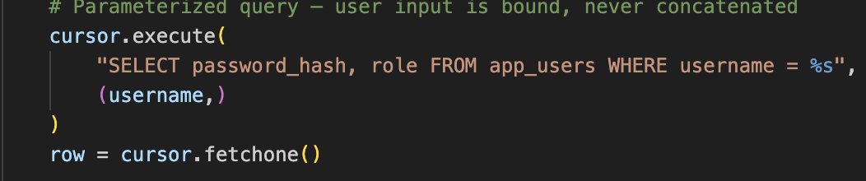
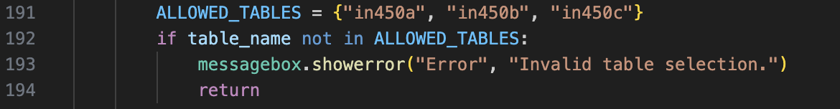

Security Change 3: Password Hashing with bcrypt

Technique Implemented
The third security change replaces plain-text password handling with bcrypt hashing. The original application, following the database login page pattern documented by GeeksforGeeks (2025), passed passwords directly to the database connection driver without hashing them at the application level. G, V. (2025) explains that bcrypt is safer than MD5 or SHA for storing credentials because it is intentionally slow and automatically generates a unique salt for each hash. These properties make both brute-force attacks and precomputed rainbow-table attacks computationally impractical. SWEBOK recommends that developers practice defense in depth, and storing hashed credentials is a concrete application of that principle (Bourque & Fairley, 2014, p. 13-26). Even if the database were compromised, an attacker would obtain only hashed values rather than usable plain-text passwords, which significantly limits the damage of a breach.

Before Code
The original application had no application-layer password management. Passwords were forwarded as plain text to psycopg2 and were never stored or compared in hashed form. The following excerpt shows the original approach.
# Password passed directly as a connection credential, never hashed
conn = psycopg2.connect(..., password=password)

After Code
The secured version uses bcrypt.checkpw() to compare the submitted password against the stored hash retrieved from the app_users table. Passwords in that table are pre-hashed using bcrypt.hashpw() at the time of account creation. The following excerpt shows the updated approach.
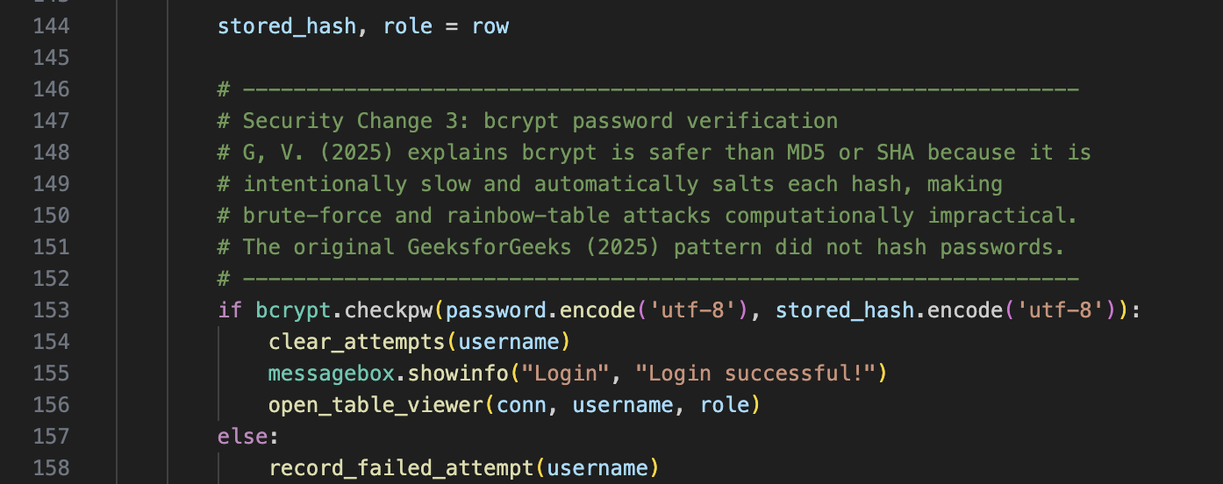

Security Change 4: Login Attempt Rate Limiting and Account Lockout

Technique Implemented
The fourth security change implements a per-username login attempt counter that temporarily locks an account after five consecutive failures within a 60-second window. Imperva (2023) describes credential stuffing as an attack in which cybercriminals use lists of compromised user credentials to breach into a system through automated, high-volume login attempts. Account lockout directly counters this type of attack by making automated attempts impractical. The SWEBOK guideline to practice defense in depth also supports this change, because rate limiting adds an independent layer of protection that remains effective even if an attacker bypasses input validation or obtains a list of valid usernames (Bourque & Fairley, 2014, p. 13-26). Failed attempts for non-existent usernames are also recorded in this implementation to prevent timing-based user enumeration, which Imperva (2023) identifies as a technique commonly used to prepare for credential attacks. Neither the w3resource (2025) nor the GeeksforGeeks (2025) reference implementations included any form of attempt limiting, making this a critical gap that the Unit 9 revision addresses.

Before Code
The original Unit 3 application had no limit on login attempts, meaning an attacker could submit an unlimited number of username and password combinations without any consequence. The following excerpt shows the original approach.
# No counter, no lockout — attempts could continue indefinitely

After Code
The secured version adds three helper functions and integrates them into the login flow. The is_locked_out() function checks whether a username has exceeded the attempt threshold, record_failed_attempt() increments the counter on each failure, and clear_attempts() resets the record on a successful login. The following excerpt shows the updated approach.

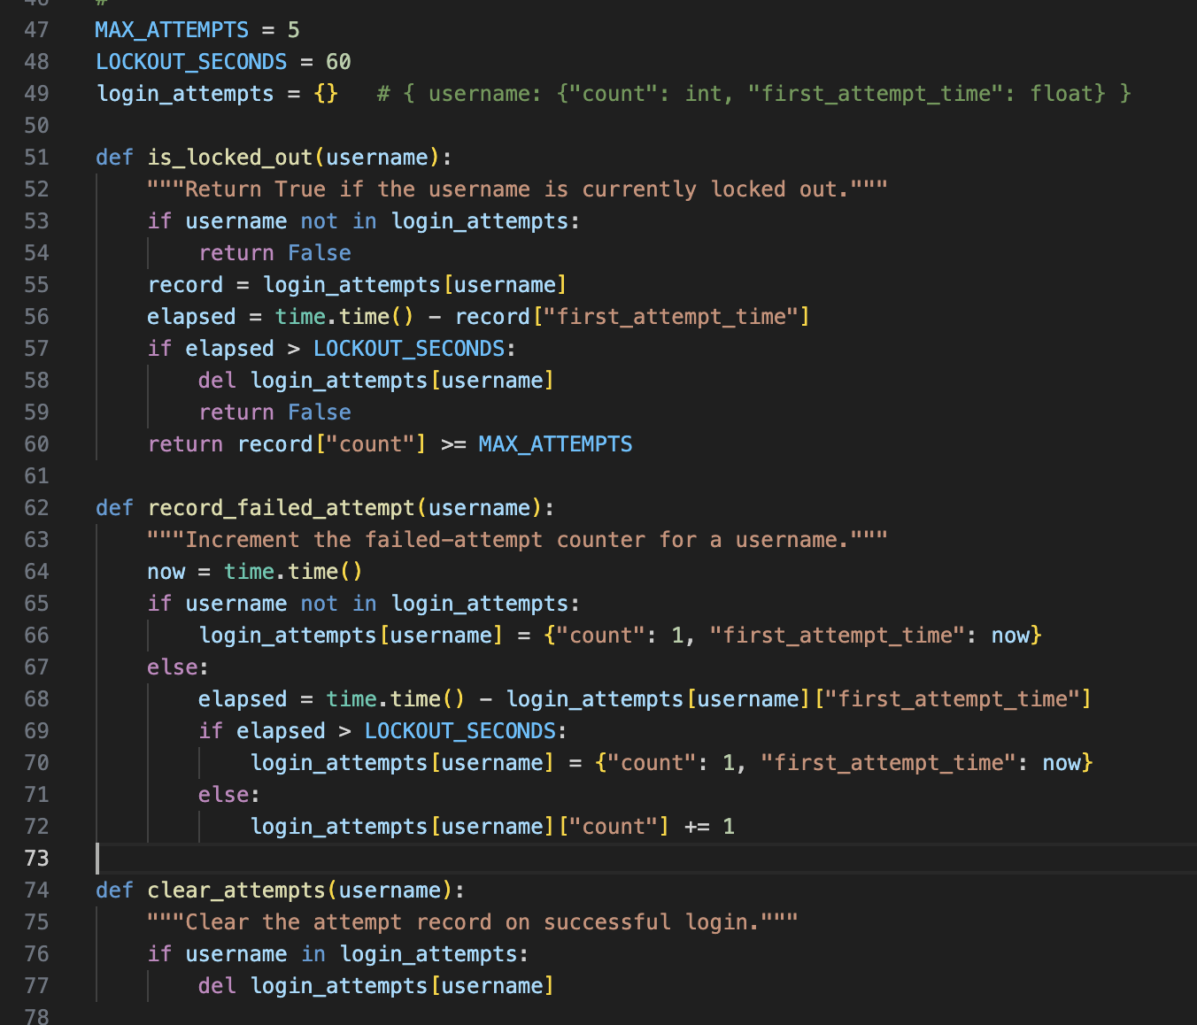

Conclusion
The four security changes applied to the Unit 3 project collectively implement a defense-in-depth strategy that addresses multiple attack vectors documented in the source literature. The original application was built on functional login patterns from w3resource (2025) and GeeksforGeeks (2025), which are appropriate starting points for learning GUI and database integration but are not designed with security hardening in mind. Input validation ensures that malformed or unexpected data is rejected at the boundary of the application, consistent with CERT's recommendation to validate all input as the first line of software security (Bourque & Fairley, 2014, p. 13-26). Parameterized queries and the introduction of an application service account eliminate the SQL injection risk that Amezola (2023) identifies as one of the most common and damaging vulnerabilities in database-connected applications. Password hashing with bcrypt ensures that stored credentials remain protected even in the event of a database breach, applying the slow-hash advantage that G, V. (2025) demonstrates over faster but weaker algorithms such as MD5 and SHA.
Login rate limiting and account lockout directly counter the credential stuffing attacks described by Imperva (2023), where automated tools submit large volumes of login attempts in rapid succession. Together, these changes transform the application from one in which a single vulnerability could expose the entire database and all user credentials, to one in which multiple independent controls must be defeated simultaneously for an attack to succeed. Bourque and Fairley (2014) establish in SWEBOK that security is best built into every phase of the software development lifecycle rather than added as an afterthought, and that principle guided all four changes documented in this paper. The result is an application that is meaningfully more resistant to the most common categories of web application attack than the original Unit 3 implementation.

References
Amezola, M. (2023, February 9). Protecting your code from SQL injection attacks when using raw SQL in Python. Medium. https://medium.com/@miguel.amezola/protecting-your-code-from-sql-injection-attacks-when-using-raw-sql-in-python-916466961c97
Bourque, P., & Fairley, R. E. (Eds.). (2014). Guide to the software engineering body of knowledge (SWEBOK) (Version 3.0). IEEE Computer Society.
Cymulate. (2025, September 7). Input validation. https://cymulate.com/cybersecurity-glossary/input-validation/
G, V. (2025, December 2). BCrypt vs MD5 SHA: Why BCRYPT is safer for member ids [LinkedIn post]. LinkedIn. https://www.linkedin.com/posts/vaishnavi-g-a87961224_why-bcrypt-is-better-than-md5-or-sha-for-activity-7401453825334898690-jEMO/
GeeksforGeeks. (2025, July 12). Create MySQL database login page in Python using Tkinter. https://www.geeksforgeeks.org/python/create-mysql-database-login-page-in-python-using-tkinter/
Imperva. (2023, December 20). What is credential stuffing: Attack example & defense methods. Imperva Learning Center. https://www.imperva.com/learn/application-security/credential-stuffing/
w3resource. (2025, August 12). Create a login form in Python with Tkinter. https://www.w3resource.com/python-exercises/tkinter/python-tkinter-basic-exercise-16.php

